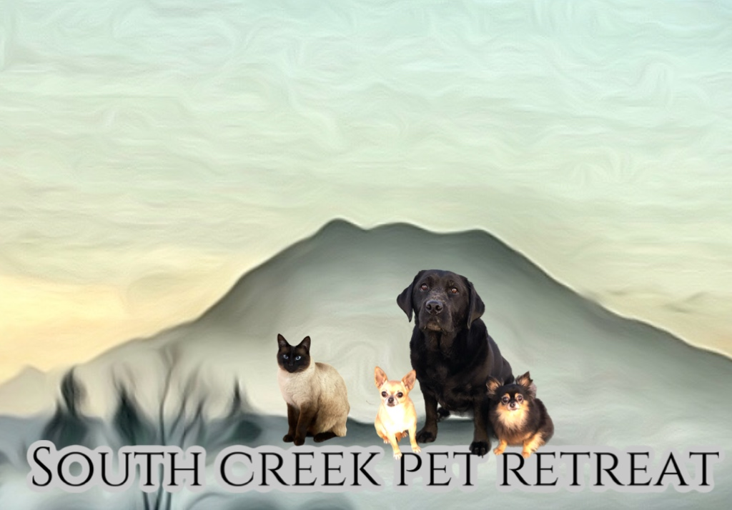

South Creek Pet Retreat LLC
Boarding Waiver and Consent Form

This agreement shall apply to all boarding visits by your dog to South Creek Pet Retreat LLC.

Please initial next to every point to indicate that you have read and understand.

I represent that I am the legal owner or authorized by the owner of the dog. ____

I represent that my dog is in good health, is current on all required vaccinations and is free of fleas ticks and has not been ill within the last 30 days. ____

I understand that my dog is fully vaccinated, the vaccines are not guaranteed, and there is a small risk that my dog may contact a contagious, disease or illness. I agreed that should occur, I am responsible for my own pets care medical attention and cost. ____

I release SCPR, its owners and any representatives from any and all liability which I or my dog may suffer, including, but not limited to injury, sickness, damage, or death, resulting from participation in daycare and boarding. ____

I understand that, although all dogs are fully supervised, incidents of injuries may occur from playing with other dogs, which includes but not limited to bites, scrapes, scratches and sprains. ____

I represent that my dog is social and has not harmed to shown threatening behaviors toward any person or other dog. I understand the SCPR reserves the right to remove my dog from the area the place, my dog in a separate holding area should my dog display and unwanted behavior. ____

I allow SCPR to contact my veterinarian should any injuries or illness require medical attention. I agree that I am solely responsible for any medical expenses acquired for my dog. ____

In the event that I authorized cannot pick up my dog at the agreed pick up time, I authorize SCPR to provide additional overnight services at my expense. ____

I understand that Boarding is charged per day not for each night. ____

With my signature below, I certified that I have read and understand the agreement and waivers. I agree to abide by the regulations, and except all terms and conditions are set out.

Signature: ____________________________________________________

Print Name: __________________________________________________

Date: _____________

Dogs name: _____________________________

Dogs Breed:____________________________________

